# Create Simple Scala Project with Intellij IDEA

Exercise Description:

This exercise will show student how to create a simple input output console scala command prompt programme that able to produce the summation of two numbers.

Requirement:

Java: java jdk 8 (1.8)

Scala: scala 2.12

Sbt: Any Latest Version.

Scala Predefine Library:

scala.io.StdIn.readline() [Scala Standard Library 2.12.8 - scala.io.StdIn (scala-lang.org)](https://www.scala-lang.org/api/2.12.8/scala/io/StdIn$.html#readLine(text:String,args:Any*):String)

scala.Console.println() [Scala Standard Library 2.12.8 - scala.Console (scala-lang.org)](https://www.scala-lang.org/api/2.12.8/scala/Console$.html#println(x:Any):Unit)

Please follow the following steps:

Step 1: Click on New Project button

Step 2: Fill in the circle information, made sure correct builder, jdk version, and scala version to use.

Step 3: Create “MyProgram.scala” in src-> main -> scala folder.

3.1 Right click on scala folder, select New, select File

3.1 Type in the source file name and press enter:

Step 4: Type in the following code in the MyProgram.scala file.

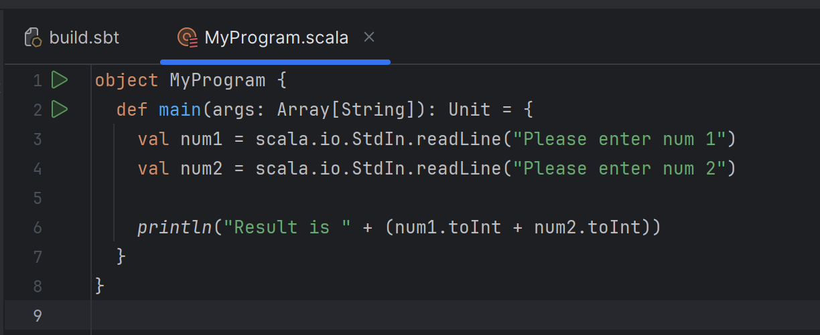

Step 5: Click on play button next to object MyProgram and select Run ‘MyProgram’

This will generate a run configuration in the run menu:

Step 6: Key in 2 numbers in the run tab

The output of the program will be the following:

Step 7: Let check the run configuration which is important setting to run program. Click on the drop down icon in the diagram and select “Edit Configurations” menu.

Step 8: Investigate the console Application “MyProgram” that is generated by Intellij, that is run in local machine with java 8 and the main class that the programme run. Program arguments is the string value that you would like to pass to main methods input parameter. We will enhance this program to a real command line program in the next step.

Step 9: Key in 2 numbers in the program arguments separated by a space and select ok:

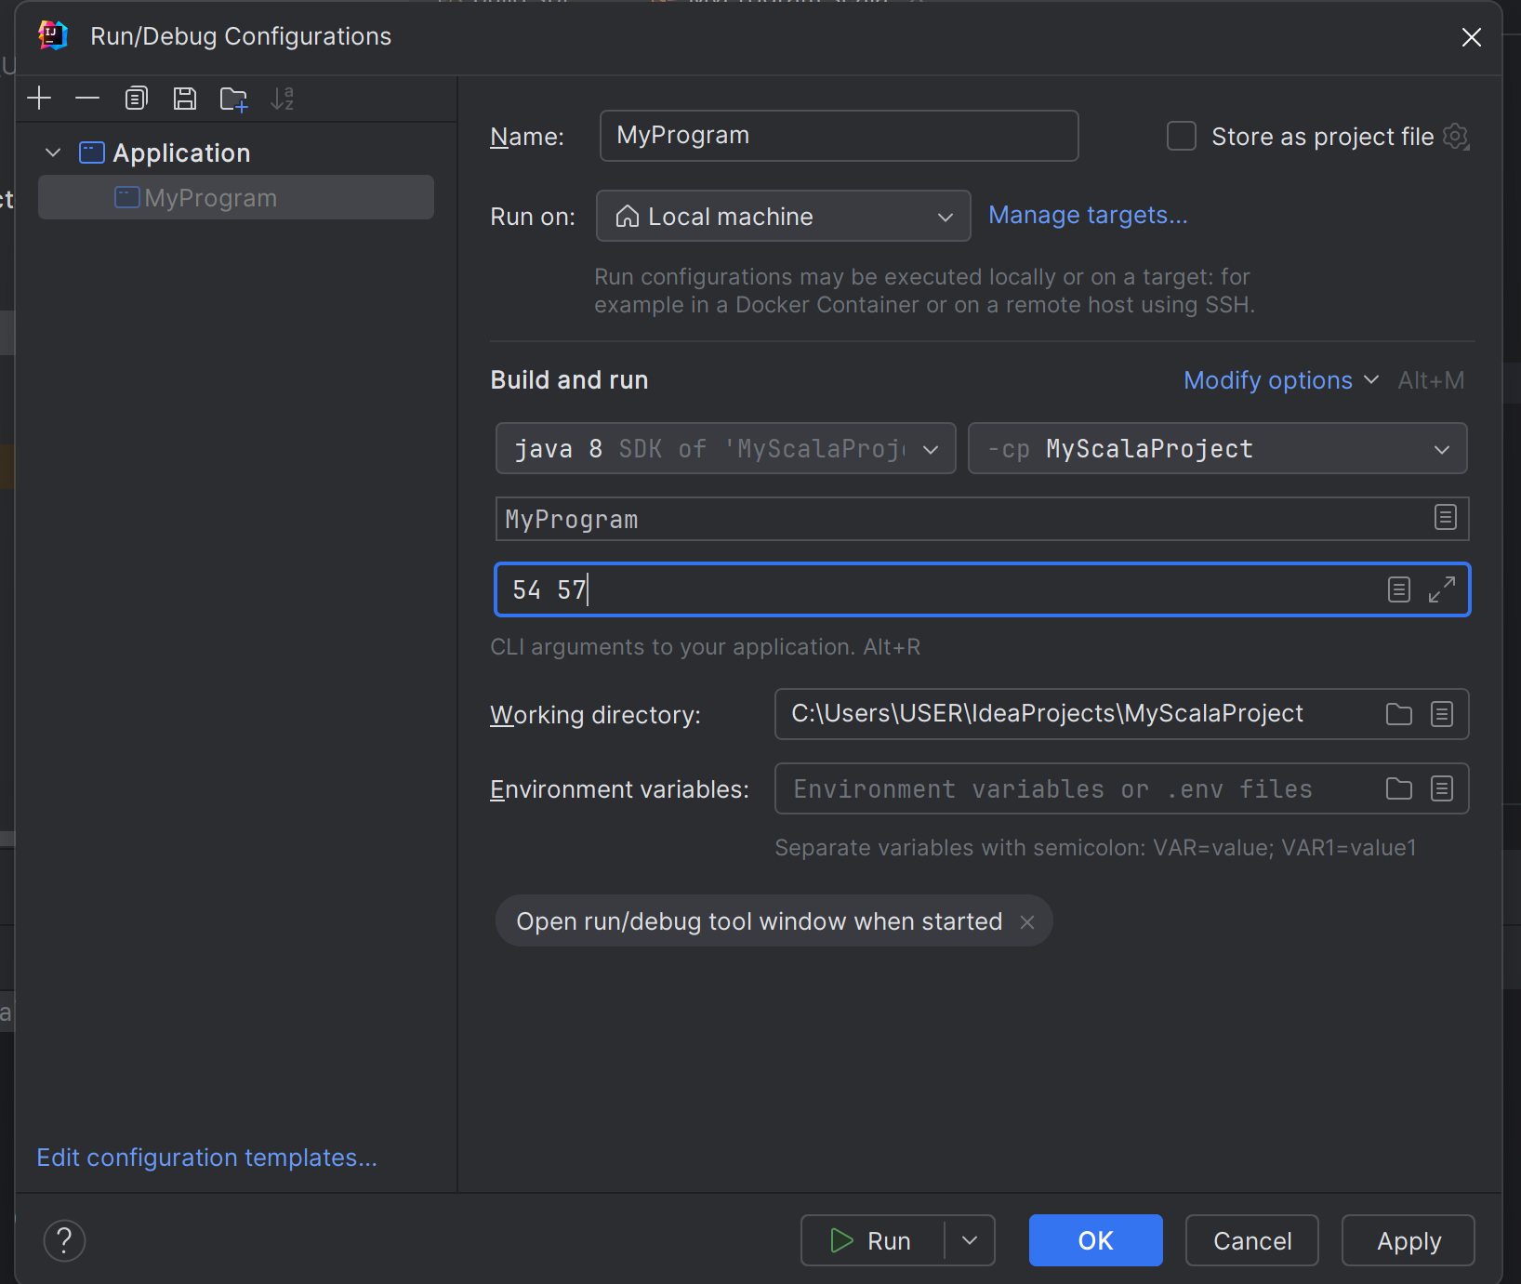

Step 10: Update the source code based on the following figure:

Step 11: Run the program again by click on the play button in run configuration menu:

Step 12: You should get following result in the run tab:

Step 13: This step will teach you about the sbt shell tab which is scala builder that could run the program:

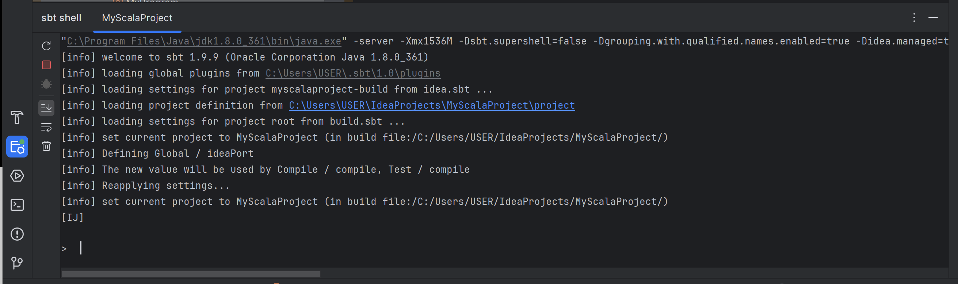

Step 14: There are few command you could use with sbt shell. There are run, build, compile. Type in “run 51 61” to run the program.

Step 15: Create a distributed jar file as a portable programme file to run on different machine. To do this, we will install sbt-assembly plugin. Right click on the project folder and select new then select file which is show in the figure below:

Step 16: Create a file call plugin.sbt

Step 17: Type the following line to install plugin to the sbt builder:

addSbtPlugin("com.eed3si9n" % "sbt-assembly" % "2.2.0")

you should get the same things in the following figure:

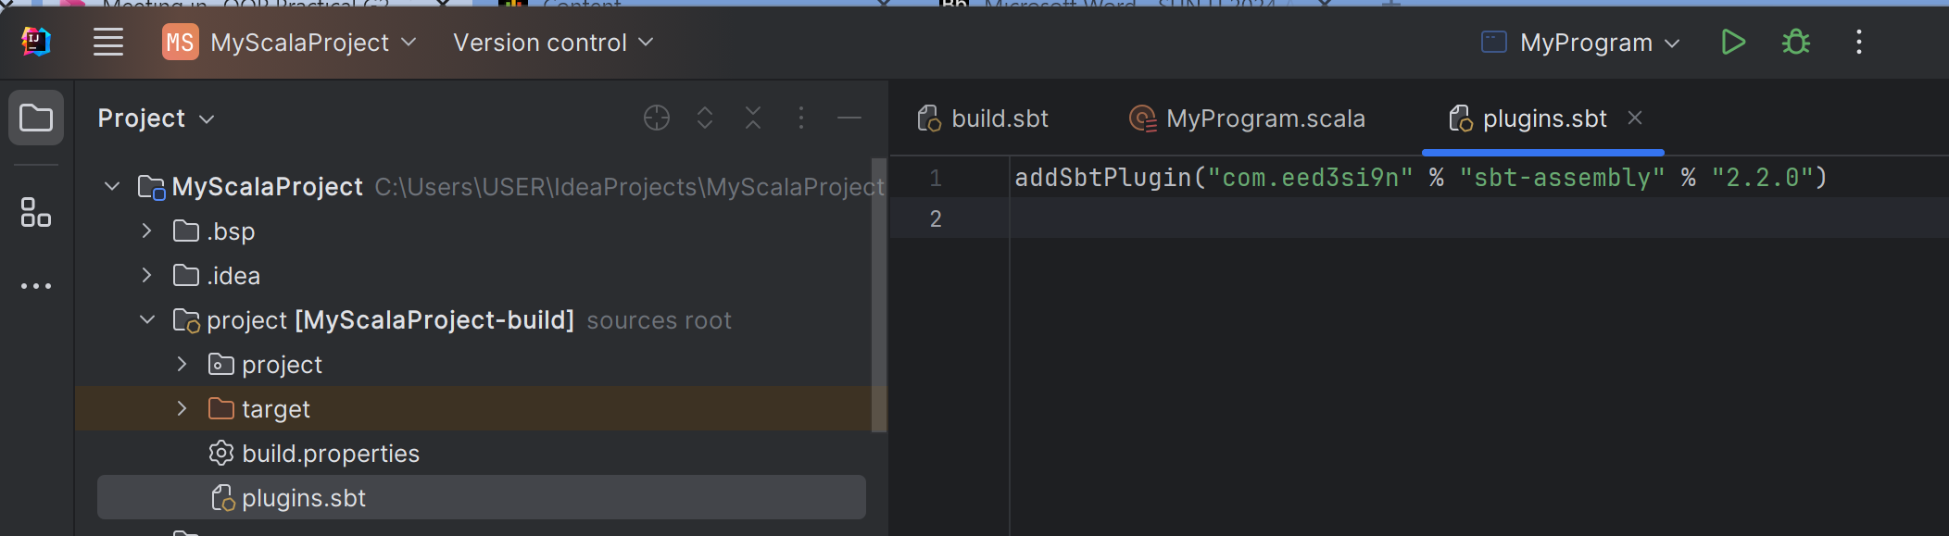

Step 18: Click on the restart button in sbt shell

Step 19: type in the command “assembly”

Step 20: Find the information where is the jar file exported.

Step 21: you may run the jar file using the terminal which is similar to window command prompt or mac terminal using the terminal tab in intellij. Click on the terminal tab

Step 21: Use the “cd” console program to change the current working directory to where the jar located

cd target\scala-2.12\

Step 22: Use the java program to run the jar file using the following command

java -jar .\MyScalaProject-assembly-0.1.0-SNAPSHOT.jar 51 57

